
Green University of Bangladesh
Department of Computer Science and Engineering (CSE)
Faculty of Sciences and Engineering
Semester: (Fall, Year: 2025), B.Sc. in CSE (Day)

Lab Report NO: 01
Course Title: Web Programming Lab
Course Code: CSE 302
Section: 232-D2

Lab Experiment Name: Basic Html (List, Table, Form)

Student Details

Name |  | ID
1. | Ashab Uddin | 232002274

Lab Date : 2025/10/07
Submission Date : 2025/10/14
Course Teacher’s Name : Feroza Naznin

Lab Report Status
Marks: ………………………………… Signature:.....................
Comments:.............................................. Date:..............................

Title of the lab report: Prepare a detailed lab report describing the development and application of lists, tables, and forms in HTML, based on the practical exercises performed during class sessions.
1. INTRODUCTION
In this lab report, we explored some key features of HTML. We gained practical knowledge on how to create and implement lists, tables, and forms in web pages. Lists are useful for presenting information neatly, tables help organize data systematically, and forms allow us to gather user input. Understanding these elements enables us to design clean, structured, and user-friendly web pages.

2. OBJECTIVES
- To understand and apply the ordered and unordered list tags in HTML.
- To design and create tables using HTML.
- To develop and implement forms in HTML for user interaction.
3. PROCEDURE
- Start with the HTML5 formate
- Create sections using <div> for drinks, chocolates, and menu.
- Use lists <ul> and <ol> to display drinks and chocolates.
- Create a table to show the menu items.
- Add forms with radio buttons for free drinks and checkboxes/dropdown for food order.
- Add a submit button to send the form.
- Add CSS styles in the head section.
4. IMPLEMENTATION

Head Source Code:
<head>
<meta charset="UTF-8" />
<meta name="viewport" content="width=device-width, initial-scale=1.0" />
<title>HTML Lab Report</title>

<style>
body {
font-family: Arial, sans-serif;
margin: 0;
background-color: #f4f4f4;
text-align: center;
}

h1 {
background-color: #333;
color: white;
padding: 15px 0;
margin-bottom: 30px;
}

h2 {
background-color: #333;
color: white;
padding: 15px 0;
margin-bottom: 20px;
border-radius: 0;
}

div {
margin: 20px auto;
padding: 20px;
width: 60%;
border-radius: 10px;
text-align: center;
}

ul, ol {
display: inline-block;
text-align: left;
padding-left: 40px;
}

table {
margin: 10px auto;
border-collapse: collapse;
width: 80%;
transition: transform 0.3s;
}

th, td {
border: 1px solid #333;
text-align: center;
padding: 8px;
background-color: bisque;
}

tr {
background-color: rgb(243, 203, 151);
}

table:hover {
transform: scale(1.02);
}

input, select {
margin: 5px;
padding: 8px;
font-size: 16px;
}

label[for="foods"] {
display: block;
margin-top: 10px;
}

input[type="submit"] {
background-color: rgb(88, 12, 12);
border: none;
color: white;
border-radius: 5px;
cursor: pointer;
transition: 0.3s;
}

input[type="submit"]:hover {
background-color: rgb(156, 72, 72);
transform: scale(1.05);
}
</style>
</head>

Lists in HTML Source Code:
<body>
<h1>HTML Practice Report – Lists, Tables, and Forms</h1>

<div style="background-color: rgb(173, 182, 217);">
<h2>Beverage Options</h2>
<ul>
<li>Coffee</li>
<li>Green Tea</li>
<li>Chocolate Shake</li>
</ul>
</div>

<div style="background-color: rgb(166, 190, 189);">
<h2>Sweet Treats</h2>
<ol>
<li>KitKat</li>
<li>Dairy Milk Silk</li>
<li>Ferrero Rocher</li>
</ol>
</div>

Tables in HTML Source Code:
<div style="background-color: rgb(199, 154, 120);">
<h2>Cafe Menu</h2>
<table>
<tr>
<th>Drinks</th>
<th>Desserts</th>
<th>Snacks</th>
</tr>
<tr>
<td>Lemonade</td>
<td>Brownie</td>
<td>Nachos</td>
</tr>
<tr>
<td>Cold Coffee</td>
<td>Chocolate Cake</td>
<td>Sandwich</td>
</tr>
<tr>
<td>Juice</td>
<td>Donut</td>
<td>French Fries</td>
</tr>
</table>
</div>

Forms in HTML Source Code:

<div style="background-color: rgb(177, 107, 114);">
<form action="/action_page.php">
<h2>Select Complimentary Drink</h2>
<input type="radio" id="water" name="free_drinks" value="Water">
<label for="water">Mineral Water</label><br>
<input type="radio" id="coffee" name="free_drinks" value="Coffee">
<label for="coffee">Black Coffee</label><br>
<input type="radio" id="tea" name="free_drinks" value="Tea">
<label for="tea">Green Tea</label><br><br>
</form>
</div>

Checkbox and Dropdown:
<div style="background-color: rgb(123, 189, 169);">
<h2>Place Your Order</h2>
<form action="/action_page.php">
<input type="checkbox" id="food1" name="food1" value="Burger">
<label for="food1">Cheese Burger</label><br>
<input type="checkbox" id="food2" name="food2" value="Pizza">
<label for="food2">Margherita Pizza</label><br>
<input type="checkbox" id="food3" name="food3" value="Pasta">
<label for="food3">Spaghetti Pasta</label><br><br>

<label for="foods">Choose Rice Type:</label>
<select name="foods" id="foods">
<option value="fried_rice">Fried Rice</option>
<option value="biryani">Chicken Biryani</option>
<option value="plain_rice">Plain Rice</option>
</select><br><br>

<input type="submit" value="Submit Order">
</form>
</div>

Footer Section Source Code:
footer style="margin-top: 40px; background-color: #333; color: white; padding: 10px;">
<p>Developed by Ashab Uddin | HTML Lab Exercise</p>
</footer>

5. OUTPUT

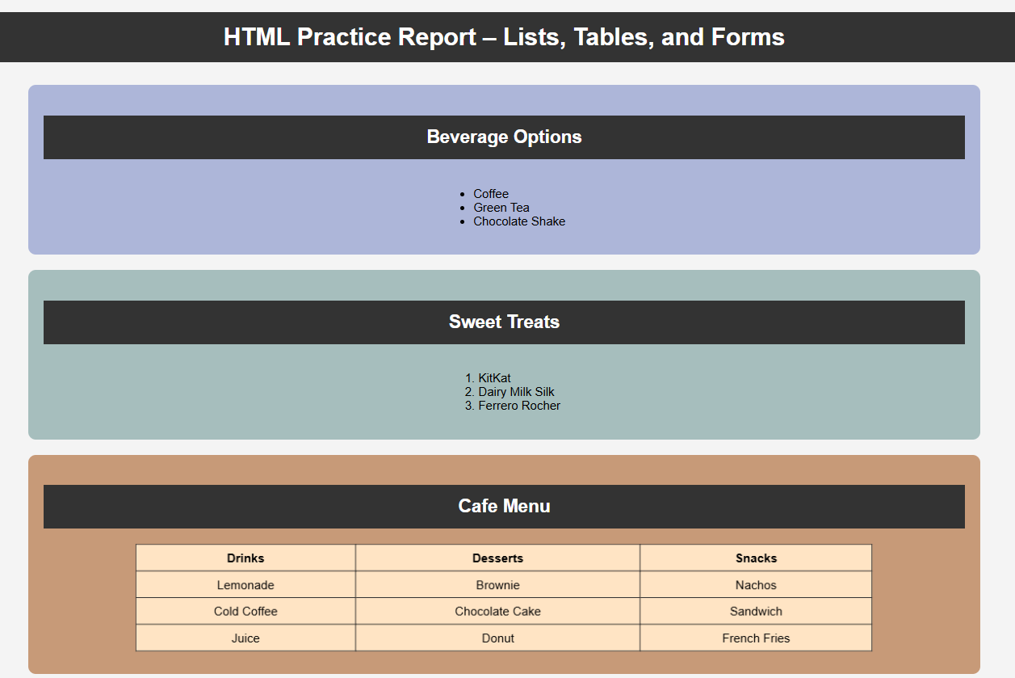
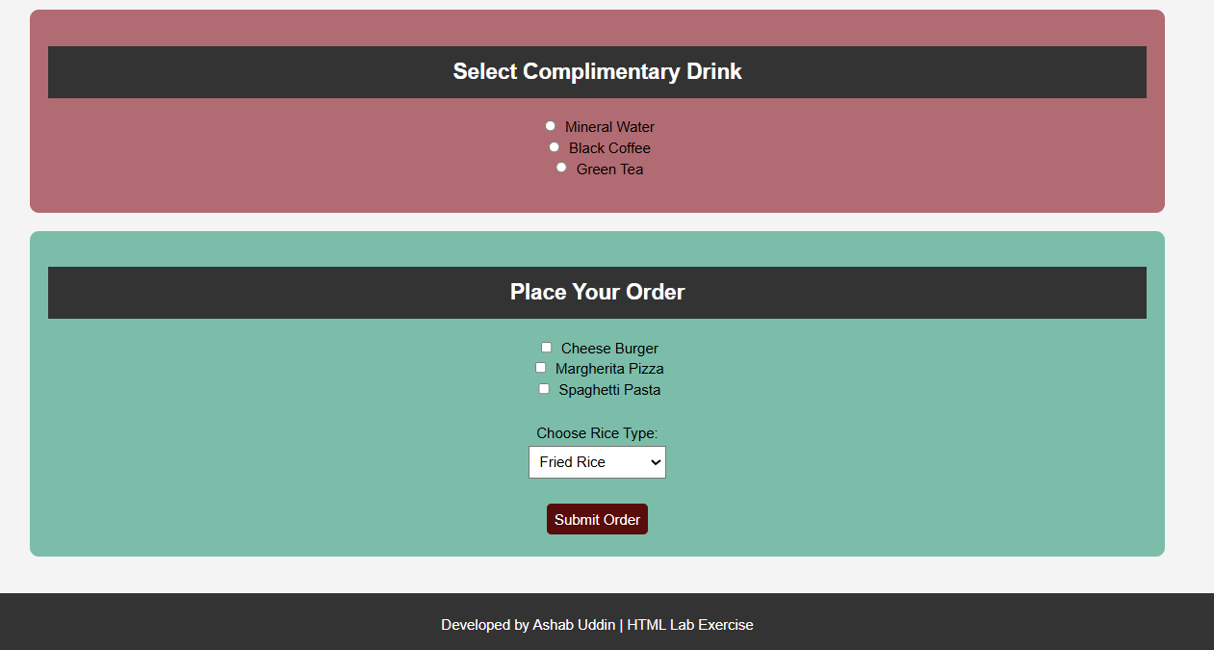

6. ANALYSIS AND DISCUSSION
This HTML project demonstrates the use of lists, tables, and forms to create an organized, interactive webpage. Color-coded sections separate content, making it easy to read. Drinks and chocolates are displayed with lists, while the menu uses a table for clear structure.
Forms allow user interaction: radio buttons for a free drink, checkboxes for multiple food items, and a dropdown for rice selection. The submit button simulates order submission.
CSS styling enhances visuals with centered content, background colors, borders, rounded corners, and hover effects, giving the page a clean and modern look.
Overall, the project shows how structured layouts, interactivity, and styling improve usability and presentation in web design.

7. SUMMARY
This HTML page displays drinks, chocolates, and a menu using lists and a table, and allows users to order food with forms, styled with colors and hover effects.

